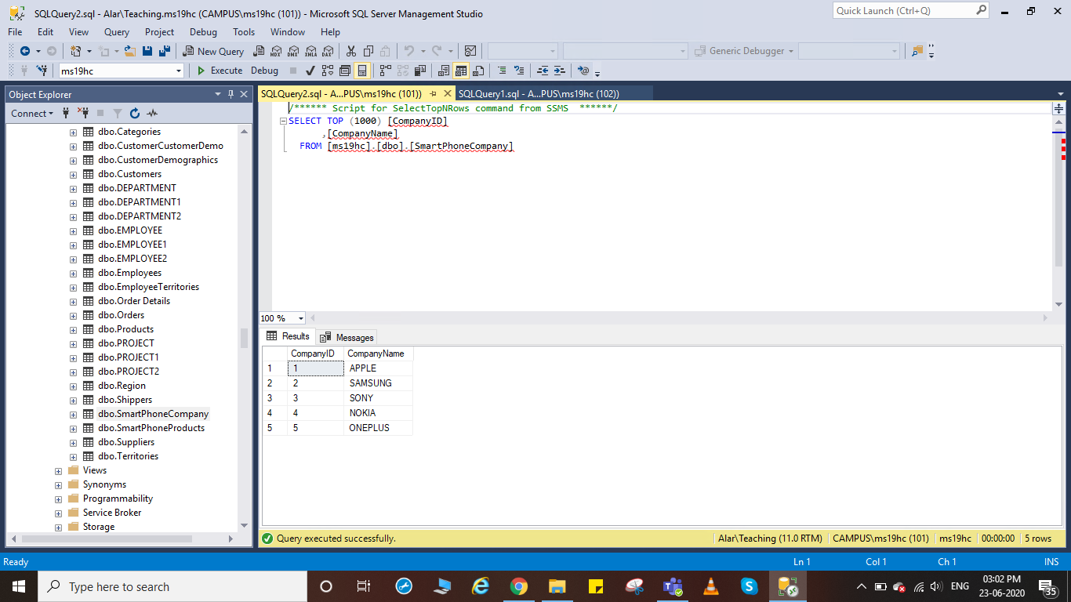

CompanyID CompanyName

1 APPLE

2 SAMSUNG

3 SONY

4 NOKIA

5 ONEPLUS

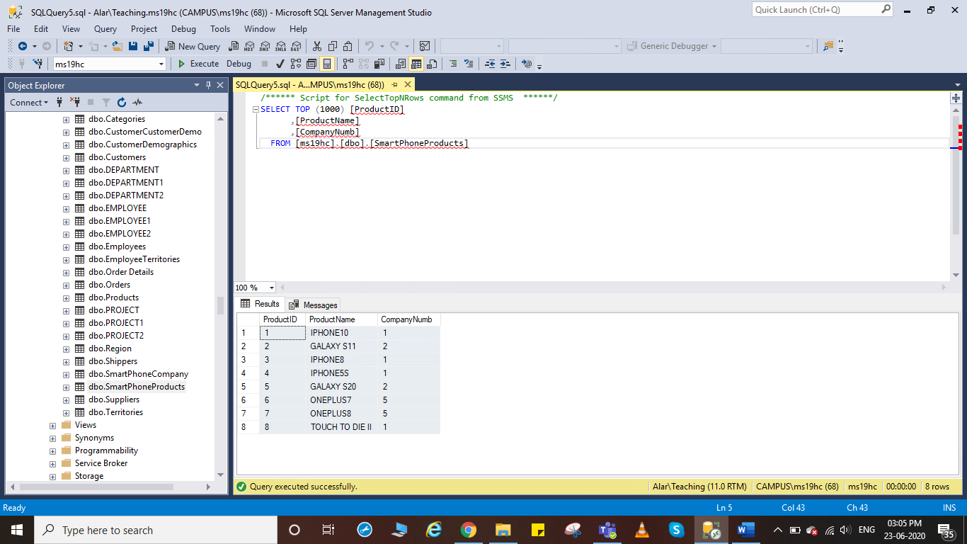

ProductID ProductName CompanyNumb

1 IPHONE10 1

2 GALAXY S11 2

3 IPHONE8 1

4 IPHONE5S 1

5 GALAXY S20 2

6 ONEPLUS7 5

7 ONEPLUS8 5

8 TOUCH TO DIE II 1